

2018 Toyota 2.5L A25A-FKS Engine Tested with Tier 2 Fuel – NCAT Test Report

**SUGGESTED CITATION:** *2018 Toyota 2.5L A25A-FKS Engine Tier 2 Fuel – Test Data Package*. Version 2020-07. Ann Arbor, MI: US EPA, National Vehicle and Fuel Emissions Laboratory, National Center for Advanced Technology, 2020.

**NCAT – National Center for Advanced Technology**

*National Vehicle and Fuel Emissions Laboratory* – *Office of Transportation and Air Quality*

*U.S. Environmental Protection Agency*

March 13, 2019

Mark Stuhldreher



Version: 03-13-19

Table of Contents

Purpose of Test 3

Definitions 3

Description of Test Article 3

Test Site 4

Test Cell Capabilities 4

Data Collection Systems 4

Vehicle Tethering 5

Engine Setup 6

Engine-Dynamometer Setup 7

Test Methodology 9

Test Fuel 9

Quality Procedures 9

Engine Safeties 10

Pre-Conditioning and Common Mode Check 10

Test Cell Procedures 10

Test Data Collection and Analysis 11

Cooled EGR Measurements...………………………………………………………………….16

Valve Timing Measurements.………………………………………………………………….18

Data Set Definition 24

Data Quality Control 24

Fuel Consumption Results 24

Uncertainty 27

References 31

# Purpose of Test

The purpose of this test is to characterize the performance of a 2018 Toyota 2.5L A25A-FKS engine and generate fuel map data that may be used in the ALPHA full vehicle simulation model. Test methods to measure cooled exhaust gas recirculation (cEGR) and valve timing were also developed.

# Definitions

|  |  |
| --- | --- |
| Fuel map | Engine operating map that displays contours of brake specific fuel consumption (in g/kWh) on a grid of engine speeds (RPM) and engine torques (Nm) |
| Protection mode | An engine operation mode where the ECU retards ignition timing, limits load and/or runs excess fuel (λ<1) due to exhaust temperature limits being reached |
| ALPHA model | Advanced Light-Duty Powertrain and Hybrid Analysis tool |

# 

# Description of Test Article

A 2018 Toyota Camry built with a 2.5L 4-cylinder, naturally aspirated, Atkinson Cycle gasoline engine with cooled-EGR was selected for use in this testing. Table 1 describes the vehicle and powertrain used in this test program.

**Table 1: Summary of Vehicle and Engine Identification Information**

|  |  |
| --- | --- |
| Vehicle (MY, Make, Model) | 2018 Toyota Camry LE |
| Vehicle Identification Number | JTNB11HKXJ3007695 |
| Engine (displacement, name) | 2.5-liter, A25A-FKS “Dynamic Force” |
| Rated Power | 151 kW @ 6600 RPM |
| Rated Torque | 249 Nm @ 4800 RPM |
| Recommended Fuel | Regular unleaded E87 |
| Engine Features of Interest | • Direct injection & Port Injection  • Atkinson Cycle  • Cooled EGR  • VVT Electric Intake/Hydraulic Exhaust  • High induction turbulence/high speed combustion  • Variable capacity oil pump  • Electric water pump  • High energy ignition  • Friction reduction |

# 

# Test Site

This test was performed in National Center for Advanced Technology (NCAT) Test Cell 9, but the procedure is applicable to any NCAT test cells using iTest controls and RPECS data collection.

# Test Cell Capabilities

The following instrumentation, listed in Table 2, exists in Test Cell 9 although not all instrumentation listed may have been utilized during this testing.

**Table 2: Instrumentation in NCAT Test Cell 9**

|  |  |  |
| --- | --- | --- |
| Equipment / Instrument Name | Purpose/Measurement Capabilities | Manufacturer |
| Dynamometer | Absorb torque from engine and provide motoring torque to engine | Meidensha Corp.,  Tokyo, Japan |
| Torque Sensor | Measures torque | HBM GmbH,  Darmstadt, Germany |
| CVS Dilution Tunnel | Exhaust flow system | EPA |
| Coriolis Fuel Meter | Measures fuel flow rate | Emerson Micro Motion,  St. Louis, MO |
| Laminar Flow Element | Measures air flow rate | Meriam Process Technologies, Cleveland, OH |

# Data Collection Systems

Test cell data acquisition and dynamometer control were performed by iTest, a software package developed by A&D Technology, Inc., Combustion data were analyzed by an MTS Combustion Analysis System (CAS). RPECS-IV (Rapid Prototyping Electronic Control System - IV) is supplemental data acquisition software developed by Southwest Research Institute (SwRI). RPECS directly measures and logs ECU input/output (I/O) along with test cell data. Temperatures, pressures, and test cell data were sent from iTest to RPECS via CAN. The engine control and analysis systems are summarized in Table 3.

**Table 3: Engine Control and Data Acquisition Systems**

|  |  |  |  |
| --- | --- | --- | --- |
| **System** | **Developer** | **Description** | **Data Rate** |
| iTest | A&D Technology Inc., Ann Arbor, MI | Test cell automation hardware and software system that controls the dynamometer and some engine controls; collects test cell data; master data logger. | 10-100 Hz |
| MATLAB | MathWorks, Natick, MA | Software used for development of data processing algorithms for transient testing | -- |
| RPECS | Southwest Research Institute, San Antonio, TX | Crank angle-based engine control and data acquisition system that collects ECU analog and CAN data, TCU analog and CAN data, and controls torque converter lock up solenoid. | 1/engine cycle |

**Vehicle Tethering**

The objective of this benchmarking was to characterize the engine while operating in an engine dynamometer test cell as though the engine were operating in the vehicle. The engine control unit (ECU) in today’s vehicles requires communication with other control modules to monitor the entire vehicle’s operation (security, entry, key on, dashboard signals, etc.). Because the ECU needs signals from these modules to operate, the signals need to be extended into the test cell, so the ECU can send and receive signals indicating correct vehicle operation. For this benchmark testing, the wiring harnesses were lengthened to connect (tether) the ECU in the test cell to the rest of the vehicle chassis located outside the cell. The ECU signals were monitored by the data acquisition system. Figure 1 illustrates the tethered wiring harness.



**Figure 1. Vehicle and Engine Tethered Wire Harness**

# 

# Engine Setup

Figure 2 illustrates the engine configuration and sensor location in the dynamometer test cell. The sensor colors shown in the upper left corner of the figure indicate which systems are monitored.



**Figure 2: Schematic of Dynamometer Test Cell and the Engine Sensor Locations Corresponding to the Identified Systems**

The stock engine systems were used with the addition of instrumentation as follows:

* *Intake:* The stock air box and plumbing were used.
* *Exhaust:* The stock exhaust system was used including catalyst and mufflers (the figure only shows one muffler). The exhaust system outlet was connected to the constant volume sampling (CVS) dilution tunnel via 2-inch diameter tubing. CVS pressure was controlled to approximately Patm +/- 1.2 kPa, which is a variation of pressure below the required limits specified within the U.S. Code of Federal Regulations for chassis dynamometer testing.
* *Cooling system:* The stock cooling system was used, but the radiator was replaced with a cooling tower. The stock engine thermostat and electric water pump were used to control engine coolant temperature. The chassis was tested before the engine was benchmark tested and the engine coolant temperatures were observed for these tests and used as a guide for the coolant temperature set point. The cooling tower was controlled to 85°C by the test cell control system.
* *Oil system:* The engine oil was cooled by adding a sandwich oil filter manifold which allows oil to be routed to an external heat exchanger. This heat exchanger was connected to a chilled water system and controlled to 90°C by the test cell control system.
* *Alternator*: No alternator was used.
* *Front End Accessory Drive (FEAD):* The serpentine belt was removed for this testing. The water pump was electrically driven and controlled by the ECU. Any losses associated with the FEAD were not included in the final Brake Specific Fuel Consumption (BSFC) or Brake Thermal Efficiency (BTE) maps.

**Engine-Dynamometer Setup**

To gather data for this benchmarking program, the engine was coupled to the dynamometer using an automatic transmission. The high torsional stiffness of a rigid driveshaft tends to not allow the testing to replicate how the engine operates in a vehicle, particularly when idling and operating in the low rpm region of the engine’s operating map (especially below 1000 rpm). Coupling the engine to the dynamometer through an automatic transmission and torque converter allows for an accurate gathering of test data where the torque measurement is very sensitive to the engine’s torsional accelerations.

***Setup with an Automatic Transmission* –** The engine was coupled to the dynamometer via a drive shaft and through a General Motors 6L80 automatic transmission and torque converter with a torque sensor between the engine and transmission as shown in Figure 3. The GM 6L80 transmission is often used in NCAT engine benchmarking as a convenient way to allow data to be gathered throughout the complete speed range including low speed with no driveline resonance. The engine could also be started normally with the engine starter to replicate starting behavior like the vehicle. The engine could then operate at idle and low speeds with normal transmission loading and an unlocked torque converter. The overall setup in the test cell is shown in Figure 4. More complete details of this setup are described in the attached SAE paper *SAE 2017-01-5020* *Testing and Benchmarking a 2014 GM Silverado 6L80 Six Speed Automatic Transmission*. [1]

The idle fuel consumption collected with the engine mated to the GM 6L80 transmission would not be the same as idle fuel consumption with the engine mated to the actual Toyota 8-speed automatic transmission found in the 2018 Camry. This is due to the differences in torque converter K-factor and transmission parasitic drag between the two transmissions. NCAT is currently testing the Toyota 8-speed transmission and plans to obtain specific idle fuel consumption data for this 2018 Toyota engine/transmission combination in the engine test cell.

***Special Consideration for Measuring Torque* -** Special care is required for measuring engine torque and other sensors that are sensitive to engine cyclical dynamics. These signals become more sensitive when mounting the torque sensor between the engine and transmission as required for the engine setup used for this testing. When these sensors are sampled in a time domain at 100 Hz, signal aliasing occurs and distorts the reported signal values. These sensors cannot be correctly sampled at 100 Hz and must be sampled in the engine crank angle domain. The method consists of sampling the torque sensor output voltage with a high-speed data acquisition system, in this case RPECS, and averaging the samples over one engine cycle. The averaged value is then logged to iTest.

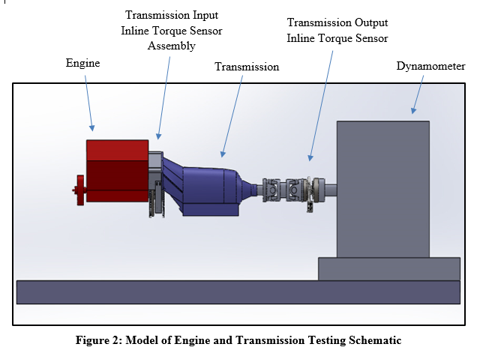

**Figure 3: Engine and Transmission Setup with Torque Sensors**

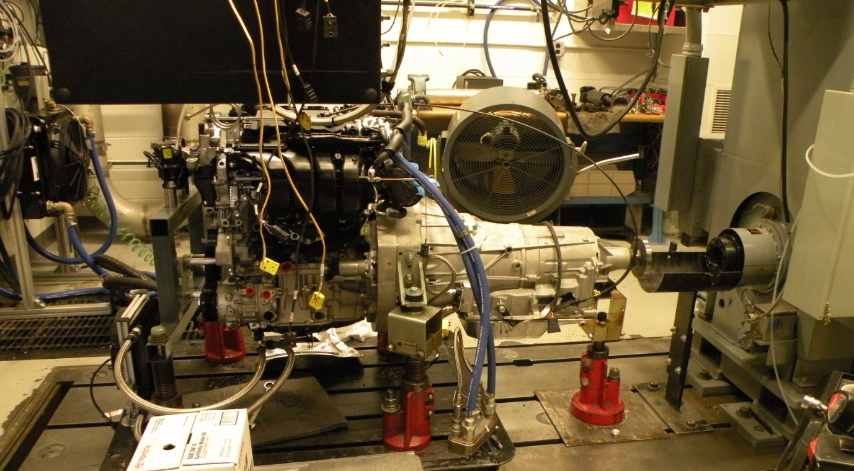

**Figure 4: Engine and Transmission Setup in the Test Cell**

# 

# Test Methodology

## Test Fuel

The primary properties of the Tier 2 fuel used in this test program are shown in Table 4 below. A detailed summary of the fuel analysis performed, and results measured for the Tier 2 fuel utilized in the test program can be found in the file: *6– NVFEL* *Fuel Analysis Report 26864.pdf*.

**Table 4. Fuel Properties for FTAG 26864**

|  |  |  |  |  |
| --- | --- | --- | --- | --- |
| Parameter Description | Test Fuel Specifications  (40 CFR §86.113-04) | Reference Procedure | Measured Results | Units |
| Research Octane (optional) | 93 (minimum) | ASTM D2699; ASTM D2700 | 97.6 | RON |
| Octane Sensitivity (optional) | 7.5 | ASTM D2699; ASTM D2700 | 8.6 | RON-MON |
| Hydrocarbon Composition (vol %) | | | | |
| Olefins | 10% Maximum | ASTM D1319 | 0.6 | Vol % |
| Aromatics | 35% Maximum | ASTM D1319 | 30.2 | Vol % |
| Total Sulfur, wt.% | 0.0015-0.008 | ASTM D2622 | 40.0 | ppm |
| Dry Vapor Pressure Equivalent, psi (kPa) | 8.7–9.2 (60.0-63.4) | ASTM D5191 | 9.07 | psi |
| The following are provided for Reference Only and are not specified in the CFR | | | | |
| Antiknock | None | N/A | 93.3 | (RON+MON)/2 |
| Net Heating Value | None | ASTM D3338 | 18447 | BTU/lb |
| None | N/A | 42.91 | MJ/kg |
| Alcohol Content | None | ASTM D5599 | 0.00 | Vol % |
| Carbon Content | None | ASTM D3343 | 0.86633 | Weight Fraction |

# Quality Procedures

This test program is covered by the Light-Duty Greenhouse Gas Test Program: Evaluating Potential Future Vehicle Technologies Quality Assurance Project Plan (QAPP).

# Engine Safeties

Table 5 lists the limits that exist for several engine parameters. These variables were monitored to ensure component durability and operator safety.

**Table 5: Engine Safety Limits**

|  |  |  |  |  |
| --- | --- | --- | --- | --- |
| **Parameter** | **Test Parameter Name** | **Units** | **Minimum** | **Maximum** |
| Oil Pressure |  | kPag | 100 |  |
| Coolant Temperature | Coolant Temp | oC |  | 110 |
| Engine Speed | Speed | RPM |  | 6500 |

# Pre-Conditioning and Common Mode Check

Before collecting operating map data, the engine was warmed up. The engine was considered “warm” when the fuel flow rate and exhaust temperatures stabilized, and the coolant and oil temperatures were a minimum of 80 oC and 70 oC respectfully. A common mode, run with the parameters given in Table 6, was repeated at the beginning of each test to expose any potential inconsistencies that could indicate equipment wear or improper instrument calibration.

**Table 6: Common Mode Test Conditions and Criteria for Achieving “Warmed” State**

|  |  |  |
| --- | --- | --- |
| Parameter | Test Parameter Name | Condition |
| Engine Speed Setting | Speed | 2500 RPM |
| Pedal Command Setting |  | 30% |
| Coolant Temperature Criteria | Coolant Temp | 80 oC |
| Oil Temperature Criteria | Oil Sump Temp | 70 oC |

**Test Cell Procedures**

The procedure for starting up and shutting down the test cell is outlined in the file: *3b- 2018 Toyota 2.5L A25A-FKS Engine - Test Cell 9 Startup & Shutdown Procedure.* This procedure describes how to activate and operate the test cell components required to run the engine. This procedure was developed during the installation of the engine and associated hardware needed for testing prior to conducting any recorded engine mapping and testing. This procedure ensures the correct start up and shutdown of the engine, the vehicle, and the test cell equipment for the engine to operate as expected in the test cell.

# Test Data Collection and Analysis

Both steady-state and transient engine test data are collected during the benchmark testing. Two different test procedures are needed to appropriately replicate steady-state engine operation at low/mid loads and transient engine operation at high loads. NCAT’s benchmarking process gathers steady-state and transient test data points in the load regions highlighted in Figure 5.

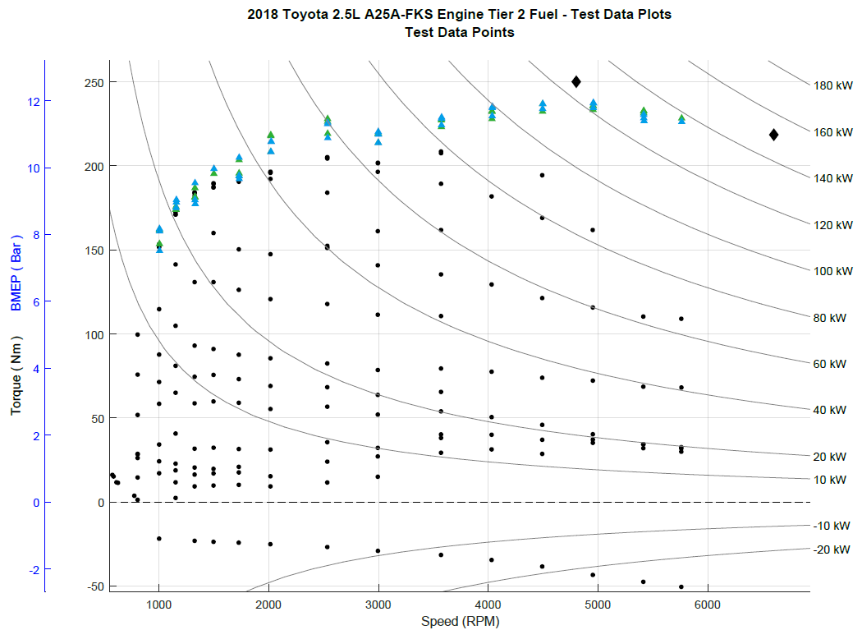

|  |  |
| --- | --- |
| **LEGEND** | |
|  | **Core Map Steady-State Operating Points** |
|  | **High Load Transient Operating Points - Initial Value** |
|  | **High Load Transient Operating Points - Final Value** |
|  | **Maximum Torque Points** (from published data) |

**Figure 5. Load Regions and Associated Engine Mapping Operating Points**

***Steady State Operating Points -*** Steady-state operating points, (black dots in Figure 5), are collected using steady state mapping procedures and are at loads generally below where enrichment is observed in this benchmarking program. The core of the steady state portion of the engine map contains the primary operating range of the engine, which is characterized by stoichiometric operation and spark timing which will result in the highest efficiency. These points generally have stable consistent engine controls (e.g. spark timing, valve timing, start of injection), allow the use of relatively slow response fuel flow measurement systems over a 30-second data collection window, and are therefore straightforward to analyze and report. The steady state test points are an average of 10-hz data over a 10 second window after stable consistent engine control is observed (e.g. spark timing, valve timing, start of injection). Low speed and low torque data points are obtained with the automatic transmission included within the test setup to avoid high torque fluctuations and produce driveline behavior similar to that found in the vehicle.

Engine operation consists of holding the engine at a fixed speed (with the engine dynamometer) and commanding a fixed pedal position. Operation at this point is held until the engine torque, fuel flow, and exhaust temperature reach a stable condition. The data is then logged for 10 seconds at 10 hertz sampling and averaged using iTest. For each engine speed, the sequencing procedure steps through an array of pedal commands from low to high (0 to 100% pedal position) and records the steady-state data for each test point. The engine speed is then incremented to the next highest rpm and the torque array is repeated. Generally, mapping points are denser in the lower engine speeds and loads areas of operation.

***High Load Transient Operating Points -*** The high load transient operating points, (blue and green triangles in Figure 5), are defined as the region where enrichment is generally observed. Data are collected with a transient procedure to more accurately characterize the transient nature of the high load engine control, which is employed to protect the engine from excessively high temperatures, avoid preignition at low speed/high load, or avoid knock at high speed/high load. For this phase of testing the engine is operated at high loads near and including wide-open throttle (WOT) using a special test procedure to measure the transient response that occurs when the engine is protecting itself at high loads.

The high load points are identified during the steady state testing when the air/fuel ratio is noted to change from stoichiometric to enriched during its stability and steady-state logging time of approximately 30 seconds. For each transient test point, the accelerator pedal is held at about 1/3 load and the engine stabilizes. The accelerator pedal is then ramped from 1/3 load to the specified high load in one second. The engine is stepped through an array of specified speed and load points in a sequence similar to the steady-state procedure. For each data point, the data are logged continuously at 100 Hz while the engine torque is ramping up to the desired torque value and operation is held at that point for 30 seconds. The data are then post-processed to determine the peak torque, final torque, transition time from stoichiometric to commanded fuel enrichment (could be essentially instantaneous), brake thermal efficiency (BTE), and other key engine criteria.

***Post-Processing of Transient Data Points*** - Once transient data have been collected for the high load points, the captured data streams must be post-processed to determine the results. These results will be used later to develop brake specific fuel consumption (BSFC) and brake thermal efficiency (BTE) maps suitable for use in vehicle simulation models. The basic calculations for transient data points include a straight-forward averaging of repeat measurements. To characterize the high load region of operation, the goal was to define an “initial” time window after the target high load torque is achieved and then a “final” time window after control stabilizes to a long-term steady state value. Once the two intervals are determined, the data are then computed as the straight-forward average of the measurements in the interval. The average values in these two intervals bookend operation in the high load region.

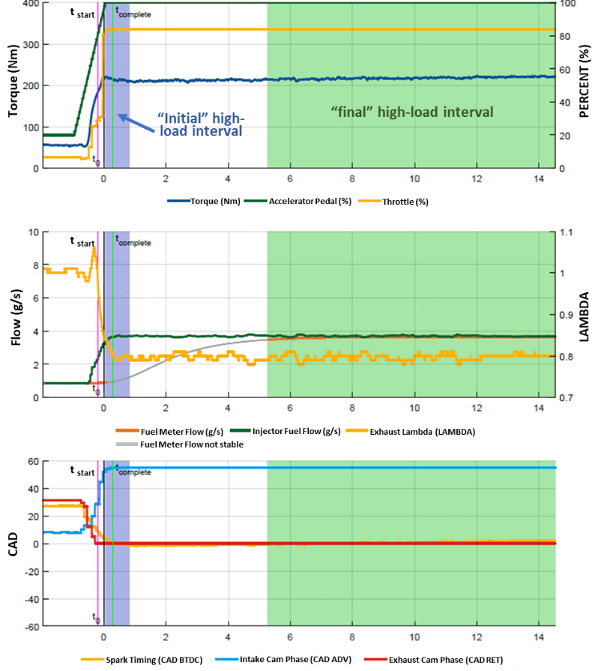

**Figure 6. Example High Load Test Showing Several Pertinent Parameters and the Windows of Data Selected** **(2017 rpm, 205 N-m)**

Within the data set, the windows are determined based upon an initial time, t0, when the engine achieves the target torque value. The blue torque line in the top chart of Figure 6 illustrates the engine torque achieving ~400 Nm. The initial high load interval, the blue highlighted area in Figure 6, captures the region of maximum torque within 2 seconds following t0.

The final high load interval, the green highlighted area in Figure 6, contains the stable torque and fuel consumption data measurements representing how the engine operates when it stays at that high load data point for a sustained period of time. The final high load interval begins when the torque and fuel flow meter measurements become stable (although no earlier than 2 seconds after t0) and ends at the end of the data stream’s sample of stable operation.

**Special Measurement of Fuel Consumption During Transient Operation**

Steady-state operation allows for the straightforward measurement of fuel consumption either by a fuel flow meter or by exhaust emissions. However, to determine fuel consumption during high-load transient operation, data from fuel injectors are used so quick changes in fueling are accurately captured. By capturing detailed measurements of fuel injector pulse duration and fuel rail pressure during steady state testing, an injector calibration can be constructed to estimate fuel consumption. For improved accuracy, the fuel rail pressure is measured via a high-speed data acquisition system synchronously with the crankshaft to minimize the distortion caused by rapid fluctuations in pressure.

The Toyota A25A-FKS engine utilizes both gasoline direct injectors (GDI) and port fuel injection (PFI) and systems. Both the PFI and GDI fuel injectors were calibrated to determine the relationship between injection pulse width and fuel consumption during high-load transient testing. Figure 7 shows the resulting calibration data.

The method of injector fuel flow correlation that was developed for this testing is shown in the equation below. The relationship between fuel rail pressure, injection duration and injected fuel quantity for a single injection event follows from the classic orifice equation.

|  |
| --- |
| $$q_{fuel}=m∙\left(\sqrt{P_{rail}}∙{dur}_{inj}\right)+b$$ |

Where: $q_{fuel}$ = injected fuel quantity (mg)

$P_{rail}$ = High pressure fuel rail pressure (MPa)

${dur}_{inj}$ = Injector open duration (ms)

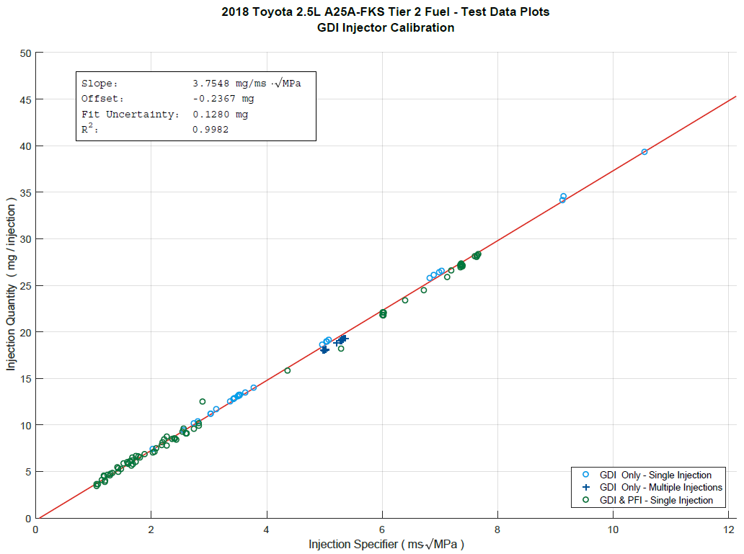

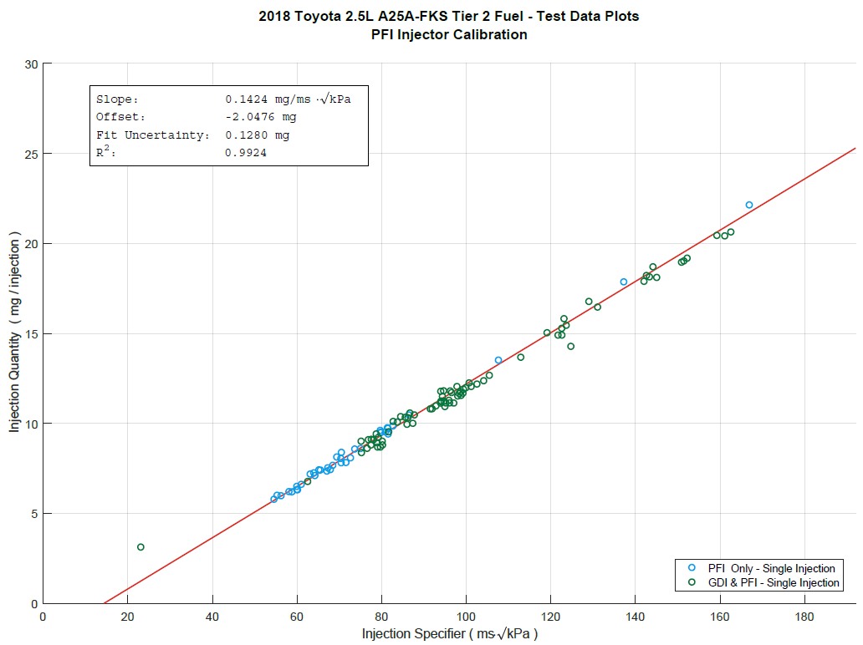

Figure 7. Fuel Flow Correlation

**Cooled EGR Measurements**

One feature of this engine is the use of cooled exhaust gas recirculation (cEGR) technology to improve thermal efficiency, reduce pumping work, and suppress knock. The configuration and routing of this engine’s EGR system is shown in Figure 8 below. To measure the amount of EGR flow though the cEGR system, the EGR manifold was replaced (connecting the EGR valve to the intake manifold) with a fabricated manifold containing a flow meter and thermocouple shown in Figure 9. The design of the system allows the stock EGR manifold to be removed and the fabricated manifold bolted directly in place. Special care was taken when designing the instrumented manifold to mimic the flow of the original manifold. The flowmeter is a turbine flowmeter calibrated for air with the addition of a thermocouple on the outlet of the flowmeter.

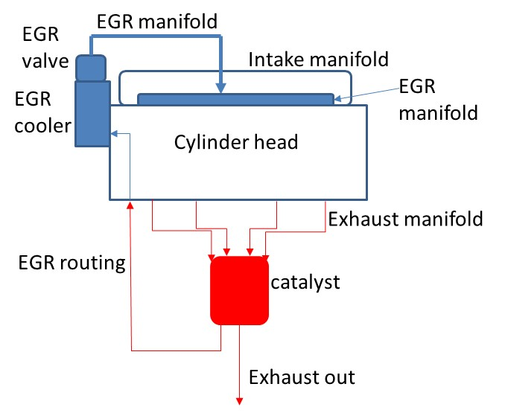

**Figure 8. EGR System and Routing**

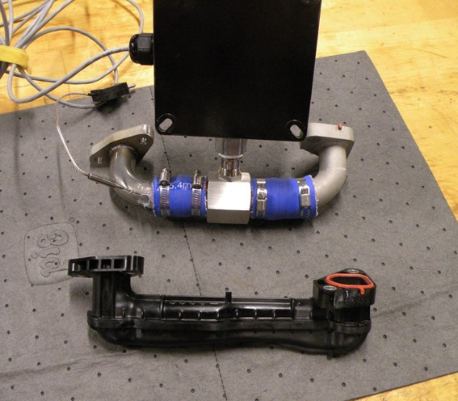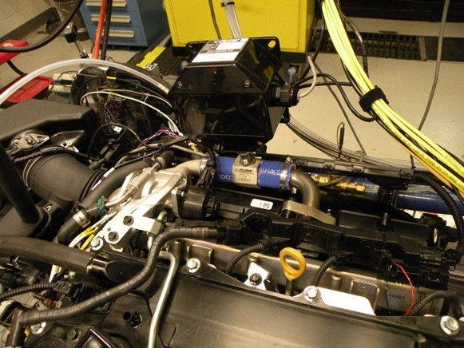

**Figure 9. Fabricated/Instrumented EGR Manifold Compared to Stock Manifold**

**Then Mounted on the Engine**

The external EGR flow was measured directly by the flow meter in actual cubic feet per minute (ACFM). This was converted to standard cubic feet per minute (SCFM) using the intake manifold pressure and EGR temperature at the flowmeter exit. This flow and the intake air flow, measured by mass air flow sensor, were used to calculate the percent EGR by volume. The influence of the fabricated manifold and flowmeter on the operation of the engine was considered negligible.

The test was conducted as a separate test from the standard steady-state benchmarking testing and consisted of running the engine and logging data using the steady state method. The number of sampling points were abbreviated from the standard steady state tests and conducted only under conditions where the ECU opened the EGR valve. The data from both steady state and this test were compared and there was no significant difference in how the engine operated, including spark timing, intake manifold temperature, mass air flow, and thermal efficiency.

The test data set containing the EGR measurement results is provided in the test data file: *4b- 2018 Toyota 2.5L A25A-FKS Engine EGR Measurements - Test Data*. The measured percent of EGR volume is shown in Figure 10. Additional contour maps for the EGR measurements are provided in *5b- 2018 Toyota 2.5L A25A-FKS Engine EGR Measurements - Test Data Plots.*

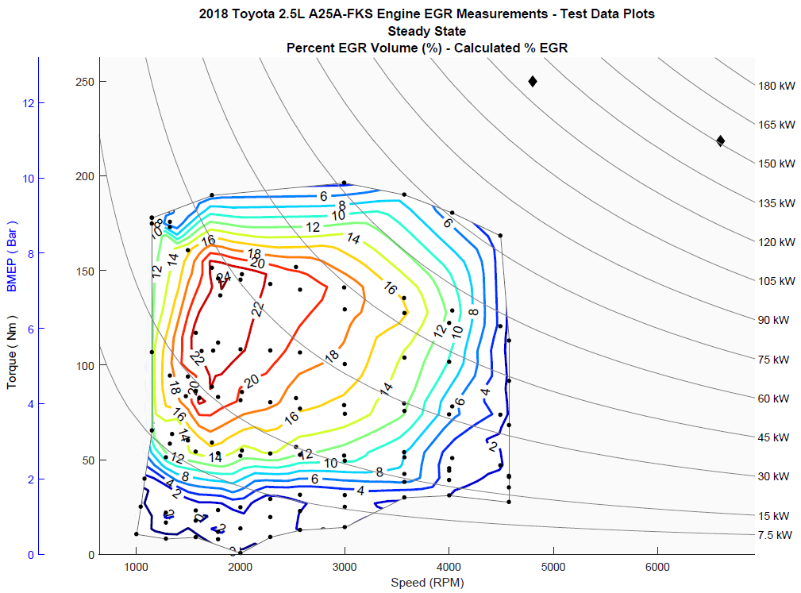

**Figure 10. Measured Percent Volume of EGR**

**Valve Timing Measurements**

Variable valve timing (VVT) enables control of many aspects of air flow, exhaust scavenging, and combustion relative to fixed valve timing engines. Engine parameters such as volumetric efficiency, effective compression ratio, and internal exhaust gas recirculation (EGR) can all be controlled by the VVT system. When testing, the precise intake and exhaust valve opening and closing, must be known to calculate and understand these parameters. A method was developed to measure the valve lift and timing under actual engine operation with active VVT control and with a pressurized oil system. This method is non-intrusive, accurate, and can be accomplished in a reasonable amount of time.

***Methods Considered to Measure Valve Lift:*** This section describes how to precisely measure valve lift for both the intake and exhaust valves in the crank angle domain. For this study, valve lift is determined by measuring the valve’s opening, closing and camshaft phase during engine operation.Several methods were considered as described below although the first three methods were not chosen due to challenges noted.

1. *Measurement with dial indicator and degree wheel* - This method mounts a degree wheel on the crankshaft and dial indicator on the valve keeper. The crankshaft is rotated by hand and the dial indicator reading is recorded for each crank angle. This method is fairly accurate but has difficulties such as the degree wheel mounting, hydraulic valve lash adjusters collapsing without oil pressure, crankshaft not rotating smoothly through the entire cycle, and the electric camshaft phaser position is unknown.
2. *Instrumentation of the cylinder head to measure valve displacement* - One type of instrumentation for this method would be to use inductive sensors. This requires the cylinder head to be removed and machined for sensor installation, which could be prohibitively expensive.
3. *Using manufacturer supplied camshaft timing information* - The manufacturer’s service manuals sometimes have valve timing information, but these often lack necessary details such as lift measurement and phase angle.
4. *Measurement with laser displacement sensor while cranking engine**(the method selected for this study)* – The setup involves removing the valve cover and mounting the laser sensor in clear line of sight to the top of the valve keeper. This method did not require any special adaptations to the cylinder head. The test is conducted by cranking the engine with the starter and measuring the valve lift (from the recorded motion of the valve keeper), camshaft, and crankshaft sensor signals.

***Capture of Valve Lift Data:*** The laser measurement method uses the instrumentation setup shown in Figure 11, while the engine is cranked rather than running at idle, otherwise normal engine lubrication can create an oil spray, or oil film on the keeper, both of which will interfere with the laser signal. Cranking the engine with the starter motor supplies enough oil pressure to fill the hydraulic valve lash adjusters but not to enough to spray oil over the valve keeper. During the cranking for this test the camshaft phase angle was held fixed by the ECU. The camshaft phase angle was measured independent of the ECU along with the laser displacement sensor readings to determine the valve lift profile.



**Figure 11. Cylinder Head Valve Train and Laser Sensor**

The analog output of the laser displacement sensor was recorded alongside the digital outputs of the camshaft position (CMP) sensor and crank position (CKP) sensor on an oscilloscope during engine cranking as shown in Figure 4. The signal trace data acquired by the oscilloscope were saved to a data file for post-processing. The blue trace in Figure 12 represents the valve lift (the laser signal), the yellow trace is the CMP, the purple trace is the CKP, the green trace shows a reference for TDC of cylinder 1. These measurements were performed for both the intake and the exhaust valve for cylinder 1 and then phased for the other cylinders.



**Figure 12. Representative Oscilloscope Screen Capture**

***Data analysis of the captured data:*** Figure 13 represents an expanded plot of a short time segment from within the dashed white rectangle visible on the captured oscilloscope data in Figure 12. The graph in Figure 13 shows the valve lift data captured from the laser sensor. The crank teeth are shown as measured by the CKP. The 0-360 signal shows when top dead center for the cylinder occurred with the camshaft phaser in the “zero” phase position. For this engine “zero” camshaft phase was defined such that it matched what the OE ECU reports over onboard diagnostics (OBD). Finally, the camshaft position sensor reveals two of the cam encoder tooth edges, labeled as CMP Edge 1 and CMP Edge 2.



**Figure 13. Analysis of Valve Lift Data**

The amount of valve lift is measured by the laser displacement sensor. However, to determine the actual crank angle of a valve lift event with respect to TDC (difference in degrees between points B and C in Figure 13), one must:

1. ***Determine location of 1 mm Valve Lift Event X relative to a reference cam encoder tooth edge*** (calledθAB as the difference in degrees between points A and B in Figure 13)

Valve opening (or closing) events were defined as 1 mm of lift and located within the filtered signal as shown in Figure 13 as a red ‘X’. The key principle here is to measure the offset of valve lift event relative to closest edge of a camshaft encoder tooth on the camshaft. Since the camshaft encoder is mechanically fixed relative to the camshaft lobes, the relative angle from valve open (or close) event (labeled with a B in a red circle in Figure 13) to the CMP rising (or falling) signal edge (labeled with an A in an orange circle in Figure 13) is constant. To determine this constant offset, the valve lift data was first filtered using the Savitzky-Golay method.

From these event locations, the nearest edge of the CMP signal (CMP Edge 2 in Figure 13) was selected. The offset from the valve event to the nearest CMP signal edge could then be measured (Figure 13, shortest dotted arrow from points A to B) using the signal recorded synchronously from the crankshaft position sensor.

Having a crankshaft position encoder with a typical 36-tooth pattern, the number of full and fractional pulses was counted from valve event to selected edge of the CMP signal, then multiplied by 10-CAD/pulse. This calculation method results in offset between valve event and camshaft encoder with minimal error utilizing the OE crankshaft encoder. A potential refinement of this method would use a higher resolution encoder installed on the crankshaft, but such a refinement would incur additional cost.

1. ***Determine location of cam encoder tooth edge relative to TDC*   
   (**called **θAC** as the difference in degrees between points A and C in Figure 13 with no camshaft phasing)

For the offset between the CMP encoder edge and the valve event to be meaningful, the position of the CMP encoder edges must be known relative to cylinder TDC (Figure 13, dotted arrow from points B to C).

**θAC** will change as the VVT cam phaser is actuated, thus it is important that a reference measurement is made at a known phase measurement. The reference phase can be at any arbitrary angle, or at a physical stop at either end of travel. However, this reference phase measurement must be utilized when calculating valve timing or an offset will be generated in the results. The sign of phase measurements must also be considered in this context as the absolute phase measurements for intake and exhaust cams are normally in opposite directions. θBC can be can be split into 3 terms, θBC@ref the measurement of θBC at the reference cam phase point, θphase@ref the assumed phasing quantity at the reference cam phase point, and θphase the relative phasing applied at a given point.

For this measurement effort, the reference angle of zero camshaft phase was chosen to match that as reported over the vehicle’s OBD. Furthermore, the OBD tool used for this measurement effort allowed for overriding the camshaft phaser control, forcing the camshafts to zero phase as reported by OBD.

1. ***Determine the location of valve opening (or closing event) with respect to TDC for a given cam phase:***  
   Finally, to determine the valve event location relative to cylinder TDC (θBC) the measurement of θAB can be subtracted from the measurement of θAC. Knowing that θAB is constant and θAC can be split, yields the equations below that provide the reference to determine the valve event location during normal operation from the phase measurement.

θVO = θBC

= θAC – θAB

= (θAC@ref + θphase – θphase@ref) – θAB

= (18.02 + 0 – 0 ) – 4.16 *teeth*

= 13.86 teeth or 138.6 CAD

***Final valve lift profile:*** The raw valve lift and sensor signals were recorded on an oscilloscope in time domain. The results were post processed to convert to crank angle domain and valve lift in mm. Figure 14 shows the intake and exhaust valve lift at zero and max phase angle CAD. Valve timings such as intake valve open (IVO), intake valve close (IVC), exhaust valve open (EVO), and exhaust valve close (EVC) can be calculated at 1 mm lift. The engine maps with measured phase angle can then be converted to actual IVO, IVC, EVO, and EVC which then can be used to calculate valve overlap Atkinson Ratio (effective expansion ratio/effective compression ratio), and actual compression ratios.

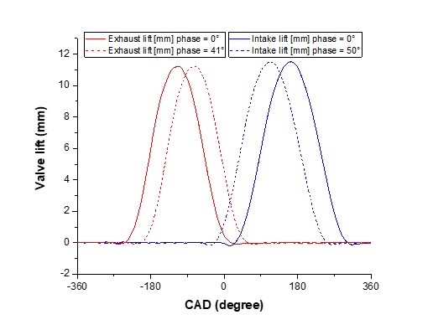

**Figure 14. Intake and Exhaust Valve Lift Profile from Laser Sensor**

# Data Set Definition

The data logged during testing included torque, fuel flow, emissions, temperatures, pressures, in-cylinder pressure and OBD/epid CAN data. The steady-state data were recorded by the iTest data acquisition system. Each steady-state mode was logged to a single output file.

The final data set containing the engine mapping test parameters is provided in the test data file: *4a- 2018 Toyota 2.5L A25A-FKS Engine Tier 2 Fuel - Test Data*. The data set includes a list of the test parameters along with the variable name, description, and calibration status. Variables that are listed “Reference Only” are not calibrated to a standard but are recorded to verify the correct operation of the engine to ensure the engine and ECU are operating without any faults or a check engine light. NCAT’s test data processor also uses this data set to produce the test data plots provided in the file: *5a- 2018 Toyota 2.5L A25A-FKS Engine Tier 2 Fuel - Test Data Plots.*

# Data Quality Control

A test parameter subset of data focused on engine efficiency was extracted from the iTest data log for review. Descriptions for the test parameter list are provided in the test data set for reference. The data set is analyzed for outlier data based on the statistical data included in the iTest data logger file. In addition, the data set is plotted and reviewed using an NCAT developed contour plotting routine. During these reviews, any outliers may be removed as needed based upon the discretion of the internal review team.

# Fuel Consumption Results

The final test data set containing the engine mapping test parameters is provided in the file: *4a-2018 Toyota 2.5L A25A-FKS Engine Tier 2 Fuel - Test Data*. The average torque, speed, and fuel flow measurements were used to determine a grid and generate fuel contour maps for Brake Specific Fuel Consumption (BSFC), shown in Figure 15, and Brake Thermal Efficiency (BTE), shown in Figure 16. Additional contour maps for the remaining test data measurements are provided in *5a- 2018 Toyota 2.5L A25A-FKS Engine Tier 2 Fuel - Test Data Plots.pdf.*

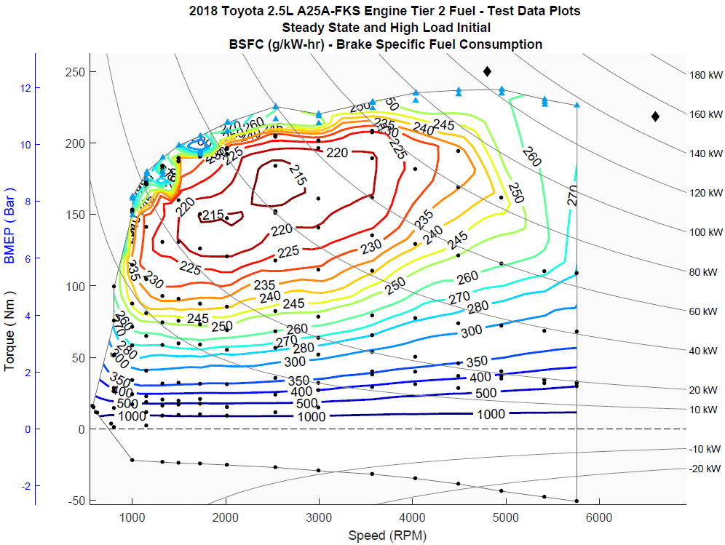 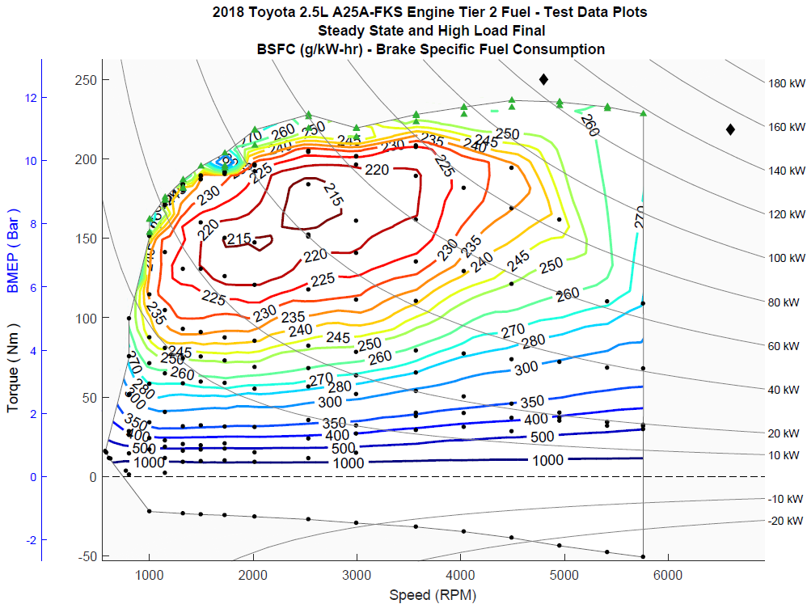

**Figure 15. BSFC in the Initial and Final Intervals**

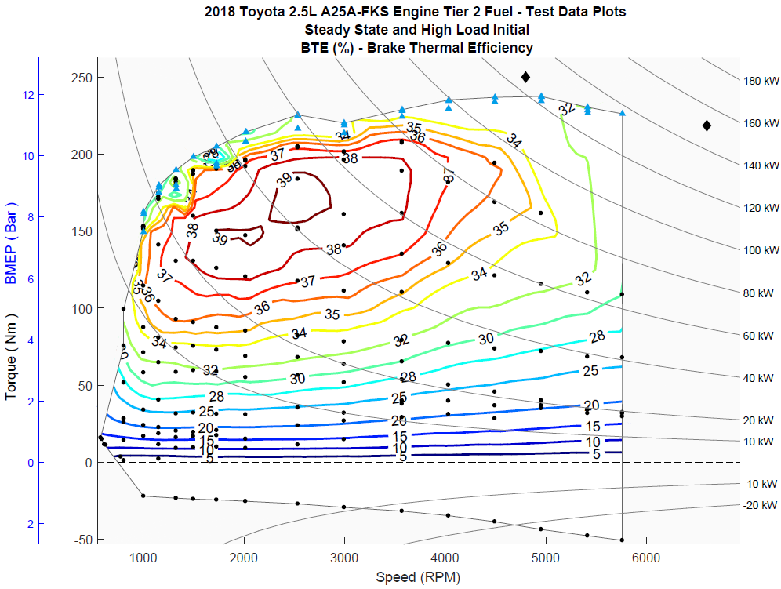 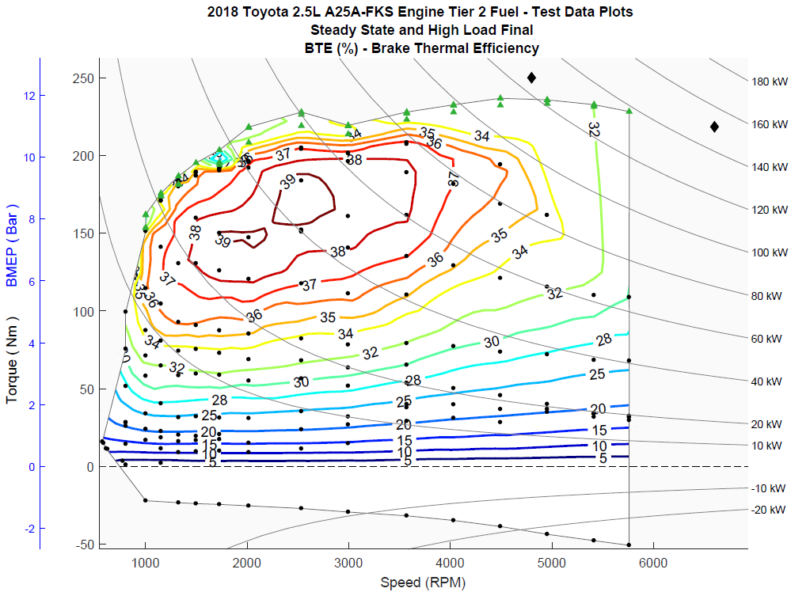

**Figure 16. BTE in** **the Initial and Final Intervals**

# Uncertainty

Sensor/signal uncertainties

The uncertainties of the signals [u(signal)] in the data set can be based on (a) the uncertainty associated with the calibration standard, (b) the uncertainty of the sensor calibration [u(calibration)], and (c) the uncertainty of the signal during operation [u(operation)]. The uncertainty associated with the calibration standard (a) is assumed to be negligible when compared to other uncertainties and thus this uncertainty is not considered for this calculation.

To determine the uncertainty of the sensor calibration (b), past calibration records are assessed and the difference between the standard and measured quantities are used to calculate uncertainty. If the sensor output and standard matched exactly, the uncertainty is assumed to be associated with the last digit of accuracy of the output. For example, the speed signal, which reads to the nearest rpm, is assumed to have an uncertainty no less than that of a uniform distribution of width = 1 rpm; i.e., 0.289 rpm. In the special case of the fuel measurement during transient operation, where the injector calibration procedure is used to determine the final fuel flow, an additional term is added to account for the uncertainty associated with the fit uncertainty in the correlation (see Figure 7), which in this case is 0.1280 mg per injection, or 4.267 E-6*(Engine rpm) in grams/sec.

To determine the uncertainty of the signal during operation (c), the standard deviations for each signal were recorded for speed, torque, and fuel flow during testing as each mode was taken. From these values, the uncertainty was calculated as

$u=σ/{\sqrt{n}}$

where *n* is the number of individual data points averaged to create the mode (for example, for the steady-state data, the total number of points is 10 Hz * 10 sec = 100 points).

Within the data set, these uncertainties were then calculated individually for each mode. In the case of the operational uncertainty of the signals and the transient correlation (when applicable), the average values over the data set are given for reference in Table 7. These values are then combined with the calibration uncertainty to perform a final calculation and determine the standard uncertainties for each signal.

**Table 7: Standard Uncertainties for Signals**

|  |  |  |  |  |
| --- | --- | --- | --- | --- |
| Signal | u(calibration) | u(correlation) average (ref) | u(operation) average (ref) | u(signal)  average (ref) |
| Speed (rpm) | 0.961 | - | 0.139 | 0.971 |
| Torque (Nm) | 0.230 | - | 0.156 | 0.278 |
| Fuel (g/sec) - steady | 0.00283 | - | 0.00144 | 0.00318 |
| Fuel (g/sec) - transient | 0.00283 | 0.0125 | 0.00144 | 0.0129 |

Uncertainty of BSFC

The variation of engine BSFC is calculated by:

$$u\left(BSFC\right)= \sqrt{{\left(\frac{∂BSFC}{∂q}\right)}^{2}{\left[u\left(q\right)\right]}^{2}+{\left(\frac{∂BSFC}{∂T}\right)}^{2}{\left[u\left(T\right)\right]}^{2} +{\left(\frac{∂BSFC}{∂ω}\right)}^{2}{\left[u\left(ω\right)\right]}^{2}}$$

or

$$u\left(BSFC\right)= \sqrt{{BSFC}^{2}\left[{\left(\frac{u\left(q\right)}{q}\right)}^{2}+{\left(\frac{u\left(T\right)}{T}\right)}^{2}+{\left(\frac{u\left(ω\right)}{ω}\right)}^{2}\right]}$$

Uncertainty of BTE

The derivation of the uncertainty of thermal efficiency is similar, with the inclusion of uncertainty in measurement of the fuel heating value, which is assumed to be small compared to other uncertainties. Assuming *u(HV)* = 10 BTU/lb,

$$u\left(EFF\right)= \sqrt{{EFF}^{2}\left[{\left(\frac{u\left(q\right)}{q}\right)}^{2}+{\left(\frac{u\left(T\right)}{T}\right)}^{2}+{\left(\frac{u\left(ω\right)}{ω}\right)}^{2}+3.1*{10}^{-7}\right]}$$

Standard uncertainties are analogous to standard deviations, such that it would be expected that, for a given set of data, the “true” value of a parameter would fall within +/-1*uc* for 68% of the data points, the “true” value of a parameter would fall within +/-2*uc* for 95% of the data points, and the “true” value of a parameter would fall within +/-3*uc* for 99.7% of the data points. The calculated uncertainty for both the BSFC and BTE measurements are shown in Figures 17 and 18.

As a check on the calculation of uncertainty, a set of eleven data points was selected at 2593 rpm and 157 Nm. The BSFC at this operation point was about 214 g/kWh, with an uncertainty of around 0.45 g/kWh. All eleven data points recorded were within a range of 213.9 to 215.0 g/kWh BSFC and within 1.3*uc* of the mean, indicating that the uncertainty calcuation is capturing the uncertainty associated with this measurement and therefore, likely representave of the uncertainty associated with the entire data set.

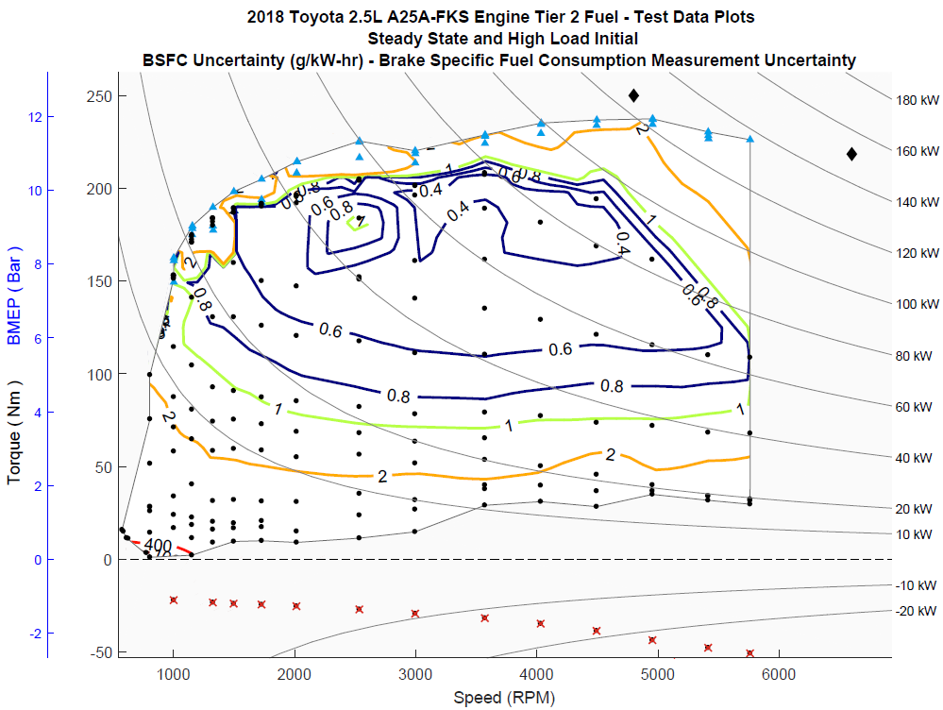

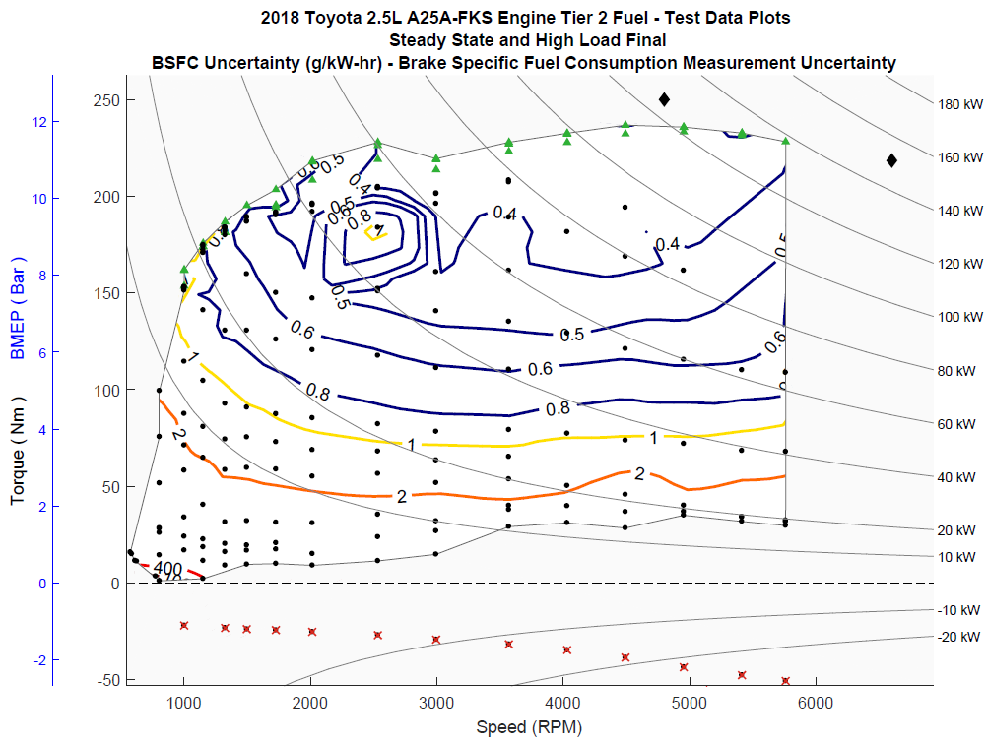

Figure 17. BSFC Uncertainty

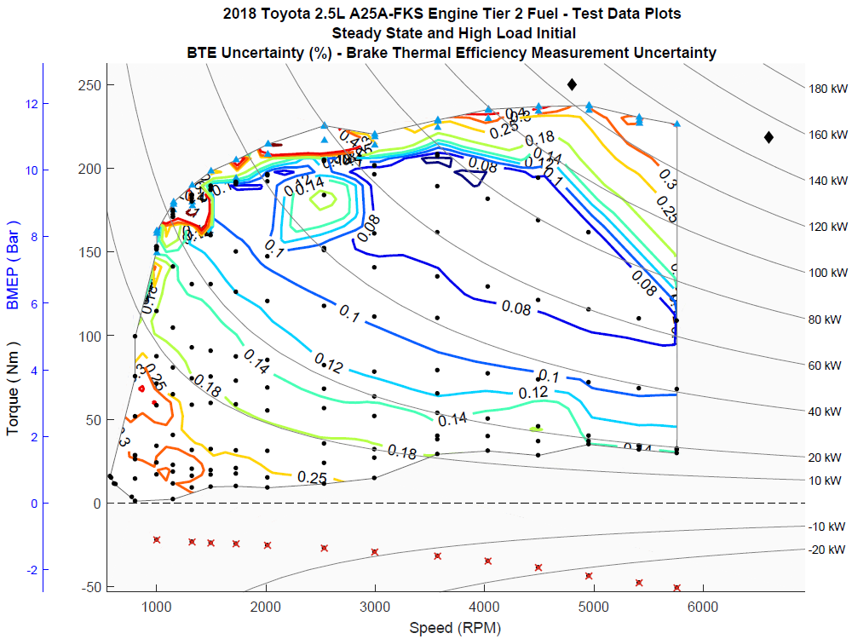

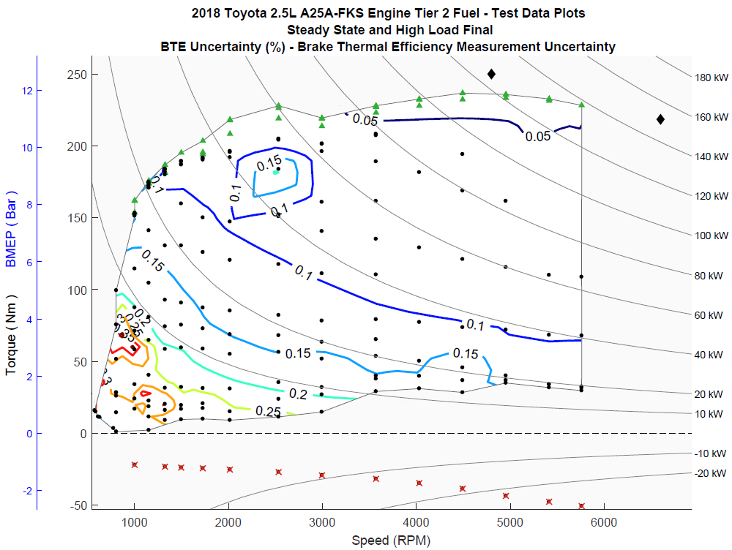

**Figure 18. BTE Uncertainty**

# References

[1] Stuhldreher, M., Kim, Y., Kargul, J., Moskalik, A. et al., “*Testing and Benchmarking a 2014 GM Silverado 6L80 Six Speed Automatic Transmission*,” SAE Technical Paper 2017-01-5020, 2017, doi:10-4271/2017-01-5020.